Identifying Fraud from Enron Email
Udacity Intro to Machine Learning – Final Project
Christopher Giler
November 24, 2016

- Introduction

- The Data

Data Exploration

The selected Enron dataset contains 146 separate data points, each for a different employee and consisting of mostly senior management of enron. Each data point includes information across 21 features, including one which classifies the employee as a “Person of Interest” (POI) in the Enron fraud. The feature breakdown, split by data type, is as follows:

Feature Type | String | Integer | Boolean
Feature | Deferral Payments | Salary | POI
Feature | Exercised Stock Options | 'To' Messages
Feature | Restricted Stock Deferred | Total Payments
Feature | Loan Advances | Bonus
Feature | Director Fees | Restricted Stock
Feature | Deferred Income | Shared Receipt with POI
Feature | Long Term Incentives | Total Stock Value
Feature | Email Address | Expenses
Feature |  | 'From' Messages
Feature |  | From This Person to POI
Feature |  | From POI to This Person
Feature |  | Other

For all 146 data points in the dataset, 18 of them are classified as POIs:

  - HANNON KEVIN P
  - COLWELL WESLEY
  - RIEKER PAULA H
  - KOPPER MICHAEL J
  - SHELBY REX
  - DELAINEY DAVID W
  - LAY KENNETH L (Founder / Chairman)
  - BOWEN JR RAYMOND M
  - BELDEN TIMOTHY N
  - FASTOW ANDREW S (CFO)
  - CALGER CHRISTOPHER F
  - RICE KENNETH D (Chief Executive – High-Speed Internet Unit)
  - SKILLING JEFFREY K (CEO)
  - YEAGER F SCOTT
  - HIRKO JOSEPH
  - KOENIG MARK E (Director of Investor Relations)
  - CAUSEY RICHARD A
  - GLISAN JR BEN F (Treasurer)
http://www.nytimes.com/2006/01/29/business/businessspecial3/10-enron-players-where-they-landed-after-the-fall.html

There are a number of features with missing values (marked 'NaN' in the dataset):

loan_advances 142
director_fees 129
restricted_stock_deferred 128
deferral_payments 107
deferred_income 97
long_term_incentive 80
bonus 64
to_messages 60
shared_receipt_with_poi 60
from_messages 60
from_poi_to_this_person 60
from_this_person_to_poi 60
other 53
salary 51
expenses 51
exercised_stock_options 44
restricted_stock 36
email_address 35
total_payments 21
total_stock_value 20
poi 0

Outlier Investigation

To remove outliers from the data, the following data points were first removed:
- 'TOTAL' -
- 'THE TRAVEL AGENCY IN THE PARK' -
- 'LOCKHART EUGENE F' -

Because the feature 'email_address' holds a different and unique string value for each data point, it would not provide any use in setting up a predictive model for the data set. For this reason, the feature was removed.

Scikit-learn's estimators assume all values in an array are numerical, and that all have and hold meaning. Some features were found to contain string-type values of numeric information, so to allow use of these features in a machine learning algorithm, all features were converted the same 'float' type data. The high number of NaN values described earlier also had to be addressed. However, simply setting these values to zero could cause the data to be skewed low, especially for features with a high count of missing values ('loan_advances', 'director_fees', etc). To avoid this bias in the data, the missing values were replaced with the median value over all data points for that feature.

df = df.apply(lambda x: x.fillna(x.median()), axis=0)

- Feature Selection/Engineering

New Features

In an effort to improve the feature set to be used in a predictive model, two new features were added. These features provide a new perspective on the data by converting the number of emails sent and received to normalized ratios, and are defined as follows:

'fraction_from_poi' – the ratio of messages received by this person that are from a POI, compared to the total number of inbox messages
'fraction_to_poi' – the ratio of messages sent by this person to a POI, compared to the total number of outbox messages

These features, were added to the dataset and list of features to be included in the feature selection stage of developing the model.

Feature Selection

A univariate feature selection approach was applied by using scikit-learn's SelectKBest algorithm The number of features were reduced select the top 10 features based on their score. Feature scaling was applied using a Min-Max Scaler in an attempt to normalize the weighting across all features. The following feature scores were obtained in using this algorithm.

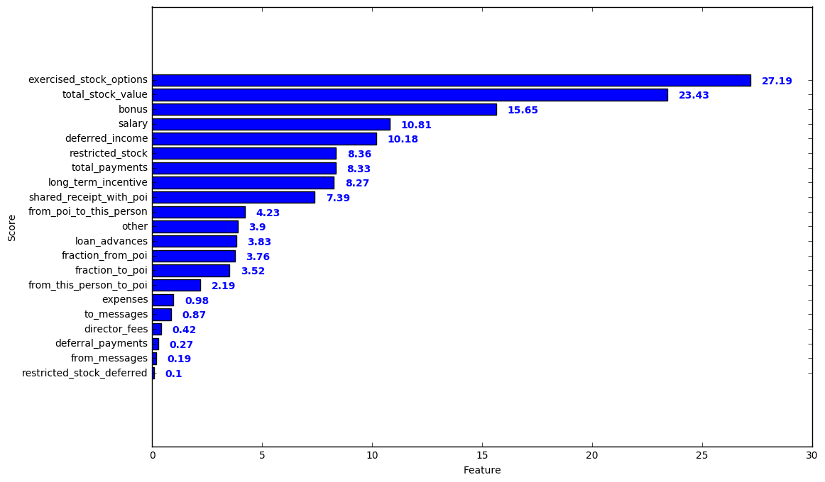
Based on this evaluation, the top 10 features selected are:
'exercised_stock_options', 'total_stock_value', 'bonus', 'salary',
'deferred_income', restricted_stock', 'total_payments', 'long_term_incentive'

Following this feature selection, the top 8 features were ranked using a method of Recursive Feature Elimination (RFE). RFE was applied on a Logistic Regression model and features were ranked from 1 to 8. Feature importance for each feature was also calculated using a Random Forest Classifier to give another set of data to consider in the final feature selection. Features were weighted independently using a min-max scaler.

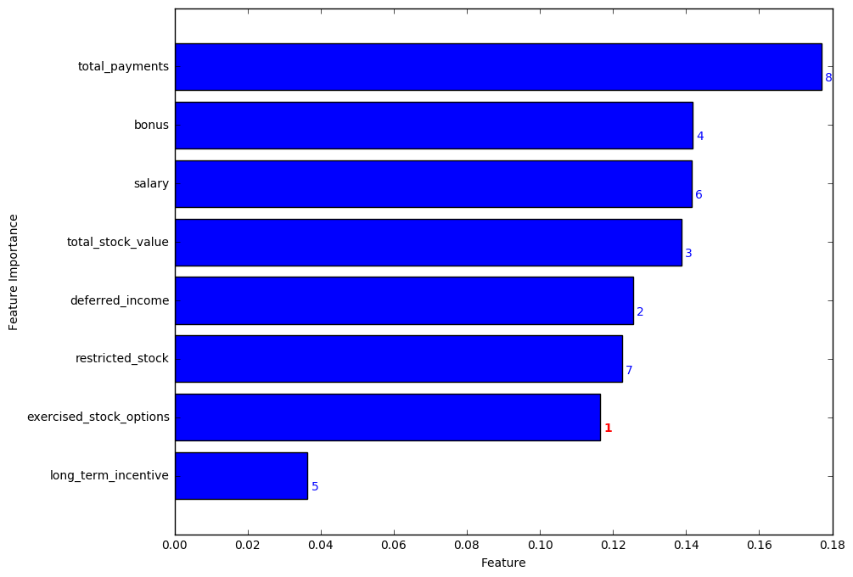
The final 5 features for our model were selected based on the two metrics calculated.
- exercised_stock_options
- deferred_income
- total_stock_value
- bonus
- salary

The remaining three features were ruled out for the following reasons:
- total_payments: showed a high feature importance, but the feature was ranked lowest among the set tested
- long_term_incentive: showed a ranking in the top 5 of all features tested, but the calculated feature importance was significantly lower than the rest
- restricted_stock: showed the second lowest ranking in the set, and was also found to have a relatively low feature importance.

Algorithm Selection and Tuning

To start the search of an optimal algorithm for our predictive model, a number of potential classifiers were selected and tested. For initial testing, the default parameters for each classifier were used, and cross-validation was applied to test each algorithm on a number of randomly selected training sets and calculate the mean score for each. The test produced three different scores for comparison.
- Accuracy: Overall statistical bias of the model
- Precision: Fraction of retrieved instances that are relevant (robustness against false positives). Target: Precision > 0.3
- Recall: Fraction of relevant instances that are retrieved (robustness against false negatives). Target: Recall > 0.3

The following results were obtained for the classifiers tested.

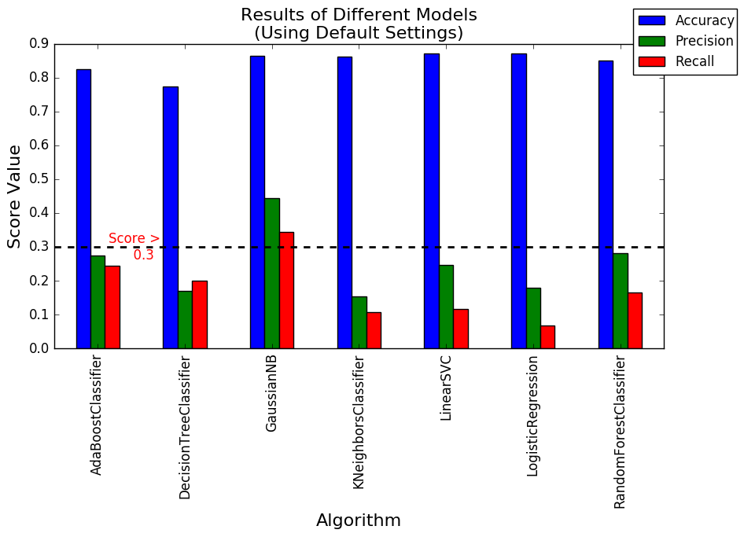
The Naive-Bayes algorithm showed the highest values of precision and recall, with both falling well over the target. It also produced a high accuracy score compared to the other algorithms tested. The cross-validation test was performed a number of times to ensure consistency in these predictions.

However, because the comparison used only default values for each algorithm's parameters, we cannot be sure that Naive-Bayes will produce the best results after the parameters of each classifier are more finely tuned. For this reason, the top 3 classifiers in terms of performance (Naive-Bayes, Random Forest, and AdaBoost) were selected for parameter tuning and optimization.

Parameter tuning is a critical step in ensuring that an algorithm is configured appropriately for the type of data it is modeling. Sklearn's GridSearchCV function was used to perform a search over the following parameter values for the Random Forest and AdaBoost classifiers.
- Random Forest: n_estimators, min_samples_split, min_samples_leaf
- AdaBoost: n_estimators, algorithm, random_state

Unfortunately, the Naive-Bayes classifier does not have the same flexibility as other classifiers within Python's scikit-learn library, so the default values were still used for this algorithm. The following results were obtained after systematic parameter tuning of the Random Forest and AdaBoost classifiers.

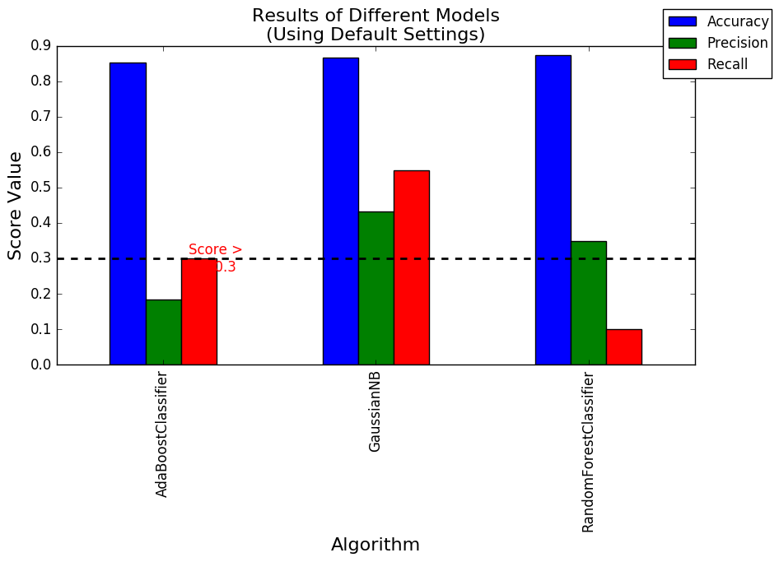
While the

sources:
stack-overflow
https://en.wikipedia.org/wiki/Precision_and_recall

